Vision Care 4 Life Patient Education Sheet
Any questions?
Call us today at:
316-682-9891

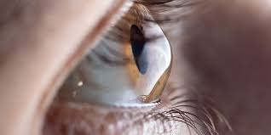
Keratoconus
Keratoconus is a condition of the eye in which the cornea thins and begins to protrude outward in a cone-like shape. This condition can cause blurry vision resulting in frequent changes in eyeglass prescriptions and light sensitivity. While there is no known cause of Keratoconus, the patient’s environment and genetic history can influence the development of the condition. Genetic factors that can contribute to keratoconus is having a close relative with a history of keratoconus, as well as the patient having other conditions such as asthma, Down syndrome, Marfan syndrome, retinitis pigmentosa, and Ehlers-Danlos syndrome.
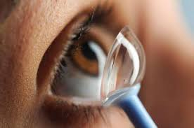
Initial treatment for keratoconus may include eyeglasses or soft contact lenses, these options can correct blurry vision in the initial stages of development. However, it is common for patients to have their prescriptions changed often. The standard of care is a scleral lens. For advanced keratoconus, scleral lenses are made to fit the patient’s cornea as it changes shape. Scleral lenses sit on the white portion of the eye, contrasting with the traditional lens which sits on the cornea. These lenses avoid touching the cornea and are extremely helpful for irregular shaped corneas.
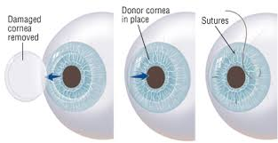
If complications develop-such as extreme thinning of the cornea or corneal scarring- a surgical option may be considered. These options include corneal cross-linking, intacs, and a corneal transplant Corneal cross-linking is a surgery that uses ultraviolet light to make the tissues of the eye stronger by adding bonds between collagen fibers of the eye. Intacs are another option for moderate cases, this treatment includes inserting synthetic rings into the cornea to flatten the affected area. A cornea transplant is a surgical treatment option for patients that suffer from corneal scarring or thinning in which all or part of the cornea is replaced with healthy donor tissue. Keratoconus is a manageable condition and there are many options to improve vision and comfort.

