As summer grows hotter, the harsh ray of sunlight is starting to shine more intensely. June is UV Awareness month. Every year, thousands of Americans are diagnosed with some form of eye cancer due to ultraviolet rays from the sun.

The most common is eyelid cancer as the skin around the eyes are extremely vulnerable. Other eye diseases such as formation of cataracts are due to UV rays and macular degeneration are due to blue light from the sun. Studies indicates that at least 90% of Americans will form cataracts by the age of 65 and currently 11 million Americans are diagnosed with macular degeneration. Individuals with light colored eyes are at higher risk of developing macular degeneration than those with dark colored eyes.
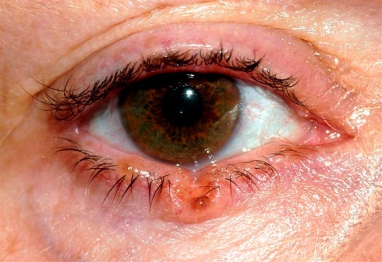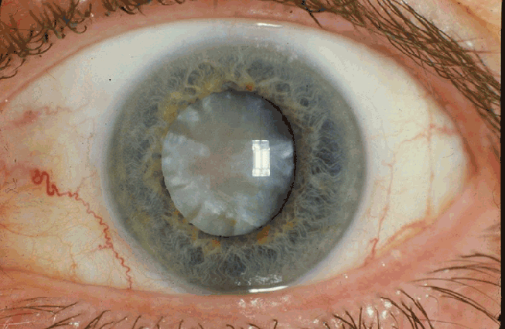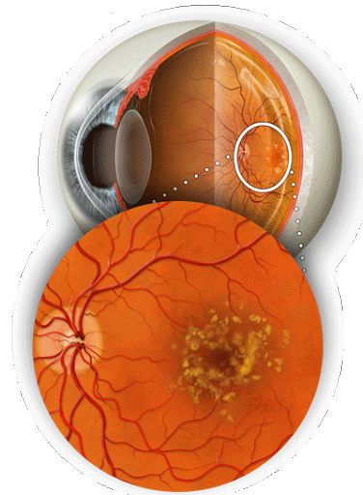

Aside from having different eye colors, it is still incredibly important for every individual to wear sunglasses to protect their eyes especially during certain hours of the day. If you are out under the sun, there are other ways to reduce the risk of damaging your eyes and skin. This includes wearing sunscreen, putting on more clothes, and wearing a hat. It only takes 15 minutes for the sun rays to damage your eyes, so remember to always wear sunglasses!
https://gph.is/2qbfEgq (AT THE END)

1st and 2nd gif!!
https://uag-earthsci.blogspot.com/2017/11/day-038-giftionary-ozone-layer.html

