Vision Care 4 Life Patient Education Sheet
Any questions?
Call us today at:
316-682-9891

Pseudotumor Cerebri
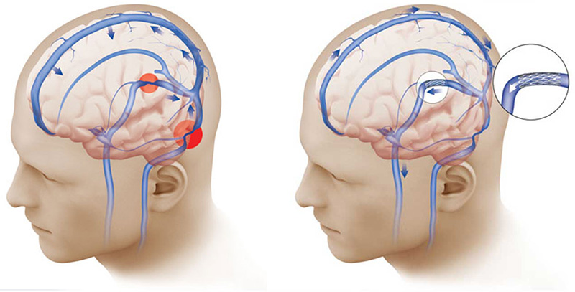
Pseudotumor Cerebri is a process affecting the brain that appears to be - but is not - a tumor. It is often reversible. The exact cause of this condition is unknown, but it may be associated with having too much cerebrospinal fluid in your skull. This fluid, which protects your brain and spinal cord, is normally absorbed into your bloodstream. Pseudotumor Cerebri may occur when this fluid isn’t fully absorbed, which causes it to build up. Major symptoms include increased pressure within the skull, headaches, buzzing around the ears, dizziness, nausea, double-vision (diplopia) and a partial or permanent loss of vision. Symptoms may also get worse during physical activity, especially when bending over. Vision loss is one of the most serious complications with this disorder, so it is very important to have regular eye exams, including formal visual field testing.

Diamox Sequels (acetazolamide) is a carbonic anhydrase inhibitor used to treat Pseudotumor Cerebri. Side effects include:
- increased sensitivity of the skin to sunlight
- changes in taste (food and drink may have a “metallic” taste)
- headaches

- Lightheadedness
- Increased amount of urine (as your body
adjusts to the medication)
- dry mouth
- stomach upset
- fatigue

