Vision Care 4 Life Patient Education Sheet
Any questions?
Call us today at:
316-682-9891

Keratoconus
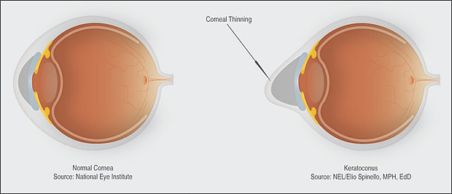
Keratoconus is a vision disorder that occurs when the normally round cornea (the front part of the eye) becomes thin and irregular (cone) shaped. This abnormal shape prevents the light entering the eye from being focused correctly on the retina and causes distortion of vision.
Eyeglasses or soft contact lenses may be used to correct the mild nearsightedness and astigmatism that is caused by the early stages for keratoconus. As the disorder progresses and cornea continues to thin and change shape, rigid gas permeable contact lenses can be prescribed to correct vision adequately. The contact lenses must be carefully fitted, and frequent checkups and lens changes may be needed to achieve and maintain good vision.
Intacs and Corneal crosslinking (CXL) are other options for people with Keratoconus. Intacs are small plastic rings that are inserted in the mid-layer of the cornea, flattening the shape and location of the cone. Most need to still use corrective lenses after this procedure. Corneal crosslinking is a minimally invasive procedure which involves applying liquid riboflavin (vitamin B2) to the surface of the eye, followed by treatment with a controlled application of ultraviolet light, to eliminate deformation and outward bulging of the cornea. CXL works by increasing collagen crosslinks which are the natural “anchors” within the cornea.
A last resort is a corneal transplant. This involves removing the center of the cornea, and replacing it with a donor cornea which is stitched into place. Most patients still need to use contacts or glasses after the surgery.

