Vision Care 4 Life Patient Education Sheet
Any questions?
Call us today at:
316-682-9891

Glaucoma
Glaucoma refers to a group of related eye disorders that all cause damage to the optic nerve that carries information from the eye to the brain. Glaucoma usually has few or no initial symptoms. In most cases, glaucoma is associated with higher-than-normal pressure inside the eye, a condition called ocular hypertension. But it also can occur when intraocular pressure (IOP) is normal. If untreated or uncontrolled, glaucoma first causes peripheral vision loss and eventually can lead to blindness. Most cases of glaucoma have few or no early symptoms, so about half of Americans with glaucoma do not know that they have it. Glaucoma is the second-leading cause of blindness in the U.S. (behind macular degeneration), and the second-leading cause of blindness worldwide (behind cataracts).
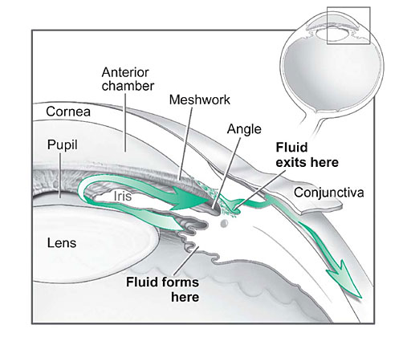
The two major categories of glaucoma are open-angle glaucoma (OAG) and narrow angle glaucoma. The "angle" in both cases refers to the drainage angle inside the eye that controls the outflow of the watery fluid (aqueous) that is continually being produced inside the eye. If the aqueous can access the drainage angle, the glaucoma is known as open angle glaucoma. If the drainage angle is blocked and the aqueous cannot reach it, the glaucoma is known as narrow angle glaucoma.
Treatment can involve medication, lasers or surgery, depending on the severity. Eye drops with medication aimed at lowering IOP usually are tried first to control glaucoma. Because glaucoma often is painless, people may become careless about strict use of eye drops that can control eye pressure and help prevent permanent eye damage. In fact, non-compliance with a program of prescribed glaucoma medication is a major reason for blindness caused by glaucoma. If you find that the eye drops you are using for glaucoma are uncomfortable or inconvenient, never discontinue them without first consulting your eye doctor about a possible alternative therapy. Anyone can take steps to prevent glaucoma, including eating a healthy diet, exercising regularly, and not smoking.

