Vision Care 4 Life Patient Education Sheet
Any questions?
Call us today at:
316-682-9891

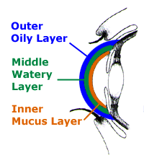
Dry Eye Syndrome
Dry Eye Syndrome is a condition in which there are insufficient tears to lubricate and nourish the eye. With each blink of the eyelids, tears are spread across the front surface of the eye, known as the cornea. Tears provide lubrication, reduce the risk of infection, wash away foreign matter in the eye, and keep the cornea smooth and clear. The causes of Dry Eye Syndrome can be an inadequate amount of tears, as well as poor quality of tears. Tear production tends to diminish due to age, various medical conditions, or as a side effect of certain medications. Tears are made up of three layers: Oil, water, and mucus. A smooth oil layer helps to prevent evaporation of the water layer, while the mucus layer functions in spreading the tears evenly over the surface of the eye. Deficiencies with any of the 3 tear layers can cause dry eye symptoms to develop. Dr. Foster recommends artificial tears of different viscosities depending on the specific dry eye problem. Severe cases require treatment with prescription.
Meibomian Gland Dysfunction (MGD)
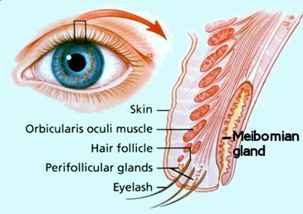
Meibomian glands are important oil-secreting glands located within our eyelids. The ducts for the glands are located along the margin of the eyelid. Meibomian glands are responsible for the supply of meibum, an oily substance that prevents evaporation of the eye’s tear film. MGD is the term used to describe problems with meibomian glands secreting the proper quantity and quality of oil into the tear film. In some cases, the oil may become thicker than normal, blocking narrow ducts that open at the lid margin. If you have dry eyes from plugged oil glands, daily lid scrubs are recommended.
Lid scrub instructions:
Use no tear bath soap and finger tips to gently scrub the eyelid margins with eyes shut, and then rinse well with warm water. (May also use commercially available prepared lid wipes or Hypochlorous Acid Spray.)

