Vision Care 4 Life Patient Education Sheet
Any questions?
Call us today at:
316-682-9891
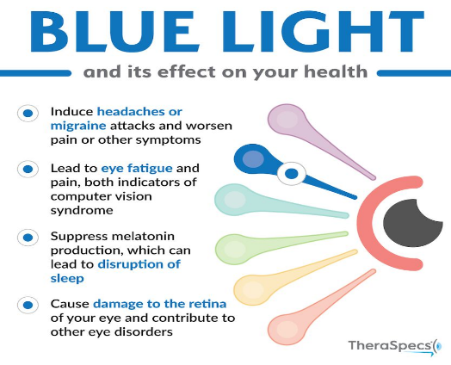

What is Blue Light?
Blue light is a color on the light spectrum of visible light that we can see. It has the shortest wavelength and the highest energy than any other color on the light spectrum. There are two main ways blue light can be emitted: naturally from the sun and from artificial blue light. Artificial blue light can come from several objects like smart phones, computers, televisions, or florescent lights.

Advantages
There are multiple benefits that blue light provides for us. One of the most important benefits is that it controls our circadian rhythm. This means that it balances our awake and sleep cycles, helping to control our hormone levels and metabolic functions. Blue light also boosts our alertness and helps us to stay awake as well. That is why you should limit your time on devices before bed to keep your sleep and awake cycles in balance.

Disadvantages
Too much artificial blue light can cause complications like interrupting your sleep and wake cycle by causing imbalance with your melatonin level, which is the hormone that regulates your circadian rhythm. Spending too much time on devices can cause eye fatigue, but there have been studies that find that too much blue light can also cause damage to your retina and in some cases can contribute to macular degeneration.
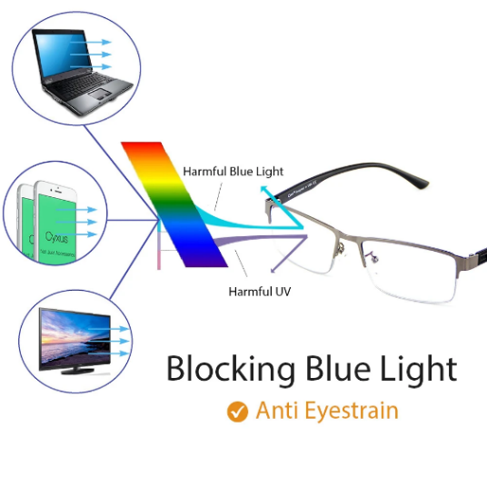

Protection
If you are outside often or are on devices all day, it is best to acquire protection from the blue light emitted to minimize the consequences that could come from too much exposure. Nowadays, an easy way is to activate a dark mode or sleep mode on your devices that will reduce the blue light emitted from the screens, or even place a timer on certain apps. If you wear glasses, an easy option is to apply a blue light filter or have transitions that would give an added coating of protection throughout the day for indoors and outdoors.

https://health.ucdavis.edu/health-news/newsroom/is-blue-light-from-your-cell-phone-tv-bad-for-your-health/2019/05
Blue light is part of the visible light spectrum -- what the human eye can see. Vibrating within the 380 to 500 nanometer range, it has the shortest wavelength and highest energy
About one-third of all visible light is considered high-energy visible, or "blue," light.
Sunlight is the most significant source of blue light. Artificial sources of blue light include fluorescent light, compact fluorescent light (CFL) bulbs, LEDs, flat screen LED televisions, computer monitors, smart phones and tablet screens.
Blue light boosts alertness, helps memory and cognitive function, and elevates mood
Inadequate exposure to blue light can also contribute to the recent increase in myopia, or nearsightedness

The glasses with blue light filters change the color of everything you see in the yellow tint. This often causes difficulties to read the screens.
Fortunately, there have been improvements in the industry and there are now blue light filters in a clear coating.
The blue light glasses could not protect skin containing also melanopsin, the photoreceptor that warns your body to warn you if it is day or night.
https://www.sboptical.ca/blue-light-protecting-computer-glasses/
Sunlight emits natural blue light; whereas, electronic devices, smart phones, smart televisions, tablets; laptops, LED lights and fluorescent lights emit artificial blue light.
Exposure to healthy amounts of natural blue and red light during the day help regulate circadian rhythms –enabling you sleep better at night, which helps control hormone levels, body temperature and immune function.
But too much artificial blue light …. interferes with sleep. It also slows the flow of melatonin, a hormone also involved in regulating the sleep/wake cycle.
Blue light can also damage your eyes, according to researchers at The University of Toledo. The light transforms vital molecules in the eye’s retina into cell killers, which can lead to eye strain, poor focus and age-related macular degeneration
You can control your exposure to blue light by adding an anti-blue light screen to your phone, changing the light settings on your laptop display to Night and wearing blue light glasses
The lenses have filters that block or absorb blue light
Blue light glasses can help regulate sleeping patterns if worn at night, according to a study conducted by the University of Houston. If you find you can’t fall asleep after a few hours of watching television, they may be worth the investment.
https://www.mdvip.com/about-mdvip/blog/do-you-need-blue-light-blocking-glasses
Use dim red lights for night lights. Red light is less likely to shift circadian rhythm and suppress melatonin.
Avoid looking at bright screens beginning two to three hours before bed.
If you work a night shift or use a lot of electronic devices at night, consider wearing blue-blocking glasses or installing an app that filters the blue/green wavelength at night.
Expose yourself to lots of bright light during the day, which will boost your ability to sleep at night, as well as your mood and alertness during daylight
https://www.health.harvard.edu/staying-healthy/blue-light-has-a-dark-side

