August: National Cataract Awareness Month
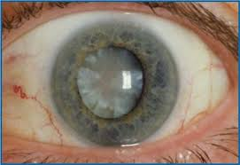
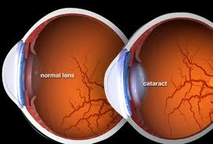
Cataracts are caused by a buildup of protein in the eye’s lens. This prevents light from passing clearly through the lens, causing some loss of vision. Since new lens cells form on the outside of the lens, all the older cells are compacted into the center of the lens, resulting in the cataract. Cataracts develop slowly and are usually not noticed until they are blocking light or causing the vision to be discolored or blurry. Cataracts can be detected by your eye care professional by performing a comprehensive eye exam. This exam includes a visual acuity test, a dilated eye exam, and a Tonometry to measure the pressure of the eye. Most cataracts develop as a cause of aging or injury that changes the tissue that makes up the eye’s lens. Other causes may include ultraviolet radiation, diabetes, hypertension, high myopia, and smoking. Although there is controversy about whether or not cataracts can be prevented, a number of studies show that certain nutrients and preventative measures may reduce your risk for cataracts. Studies have shown that antioxidant vitamins like vitamin C and E as well as foods high in omega-3 fatty acids may reduce cataract risk. You can also reduce your risk by wearing sunglasses that provide 100% UV protection. Cataracts can be treated by using strong bifocals, magnification, appropriate lighting, and other visual aids. When cataracts have progressed and have started to seriously impair the vision to the point of affecting daily life, most patients consider the option of cataract surgery. Cataract surgery is very successful in restoring vision and is the most frequently performed surgery in the U.S. During cataract surgery, the surgeon will remove the clouded lens and replace it with a plastic intraocular lens. The surgery usually lasts about an hour. Cataracts are seen by some as an inevitable part of aging. In the U.S. half of all citizens will have had cataracts by time they’ve reached the age of 80. In order to detect this early on, it is important to see your optometrist at least once a year to monitor the health of your eyes and vision.

